Question 1

Code:

<html lang="en">

<head>
<title><!-- Inside head tag we can include title,link tags but not body tag -->
Document guvi
</title>
</head>
<body><!-- Body tag should not be inside head tag-->
<div>
Lorem ipsum dolor sit amet consectetur adipisicing elit.
<div>
Guvi Geek Network
</div>
</div><!-- This div tag was missing-->
</body>
</html>

Output:

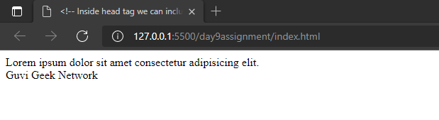

Question 2

<html lang="en">

<head>
<title><!--Body dhould not be inside head tag-->
Document guvi
</title><!-- title tag was not closed, we have to close it-->
</head>
<body><!--body tag was not there-->
<div>
Lorem ipsum dolor sit amet consectetur adipisicing elit.
<div>
Guvi Geek Network
</div>
</div><!--This div tag was not closed-->
</body>
</html>

Output:

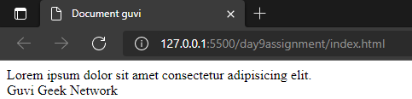

3:Design a contact us form with all fields as required.
Code:
<!DOCTYPE html>
<html lang="en">
<head>
<meta charset="UTF-8">
<meta http-equiv="X-UA-Compatible" content="IE=edge">
<meta name="viewport" content="width=device-width, initial-scale=1.0">
<title>Document</title>
<style>
body {
font-family: sans-serif;/*to change font of texts*/
}
.container {
border-radius: 5px;/*to give curve to the background grey box*/
width: 30%; /*width will be fitted to 30% of the screen*/
background-color: #f2f2f2; /*color code for background*/
padding: 20px;/*space between input form and grey background container*/
}
input,
textarea {
width: 100%;/*This will fit its width to the container which is 30%*/
}
input[type="submit"] {
background-color: green;/*button color*/
color: white;/*text color*/
}
</style>
</head>
<body>
<h2>Contact us</h2>
<div class="container">
<form>
<label for="fname">First Name</label><br><!--field to take first name input-->
<input type="text" name="fname" placeholder="You first name......"><br><br>
<label for="lname">Last Name</label><br><!--field to take last name input-->
<input type="text" name="lname" placeholder="You last name......"><br><br>
<label for="phno">Phone number</label><br><!--field to take phone number input-->
<input type="text" name="phno" placeholder="+91"><br><br>
<label for="comments">Comments</label><br><!--field to take comments -->
<textarea name="comments" name="comments" placeholder="comments..." rows="4"></textarea><br><br>
<input type="submit" value="Submit">
</form>
</div>
</body>
</html>
Output:
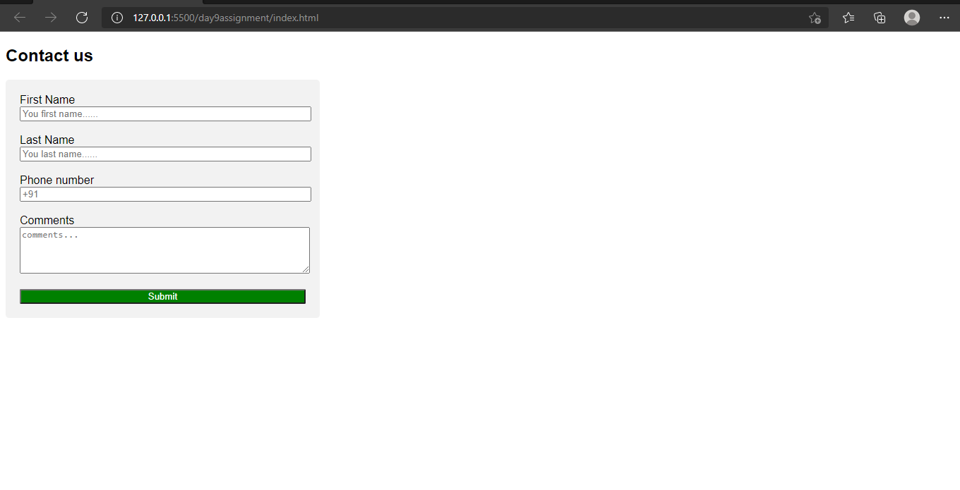

- Use certain HTML elements to display the following in a HTML page.
Code:
<!DOCTYPE html>
<html lang="en">
<head>
<meta charset="UTF-8">
<meta http-equiv="X-UA-Compatible" content="IE=edge">
<meta name="viewport" content="width=<device-width>, initial-scale=1.0">
<title>Document</title>
</head>
<body>
<ul>
<li>Programming Languages</li>
<ul style="list-style-type:circle;">
<li>Javascript</li>
<ol type='a'>
<li>Angular</li>
<li>React</li>
<li>Vue.js</li>
</ol>
<li>Python</li>
<ol type='a'>
<li>Django Framework</li>
<li>Flask Framework</li>
</ol>
<li>Java</li>
<ol type='a'>
<li>Spring</li>
<li>Maven</li>
<li>Hibernate</li>
</ol>
</ul>
<li>Database</li>
<ul style="list-style-type:circle;">
<li>Javascript</li>
<li>Python</li>
<li>Java</li>
</ul>
</ul>
</body>
</html>

Output:
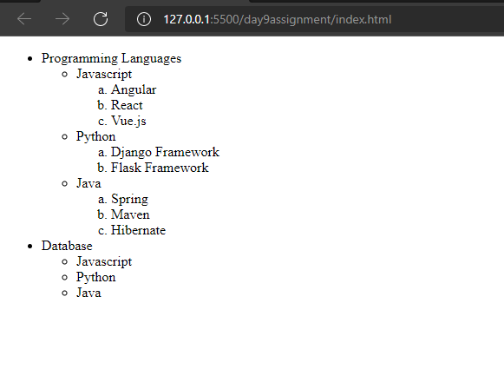

- Create an element that helps you to open the https://google.com in separate new tab.
<!DOCTYPE html>
<html lang="en">
<head>
<meta charset="UTF-8">
<meta http-equiv="X-UA-Compatible" content="IE=edge">
<meta name="viewport" content="width=device-width, initial-scale=1.0">
<title>Document</title>
</head>
<body>
<!-- target="_blank" will open linbk in new tab-->
<a href="https://google.com/" target="_blank">click me to open link in new tab</a>
</body>
</html>

Output:
Link:
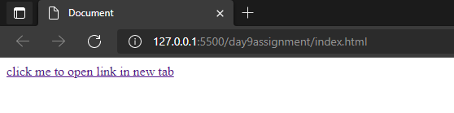
Newtab:
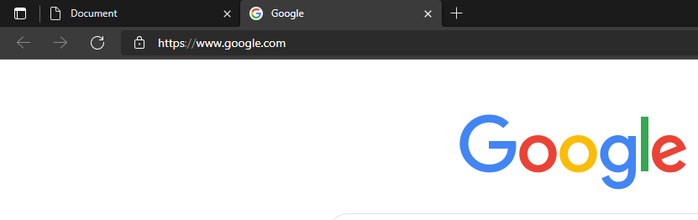

- In the form, add two radio buttons with grouping them for employee type(Salaried and own business).
Code:
<!DOCTYPE html>
<html lang="en">
<head>
<meta charset="UTF-8">
<meta http-equiv="X-UA-Compatible" content="IE=edge">
<meta name="viewport" content="width=device-width, initial-scale=1.0">
<title>Document</title>
</head>
<body>
<form>
<p>Enter the type of employee</p>
<input type="radio" name="typeEmployee" value="Salaried"><!--giving same name will group them together-->
<label>Salaried</label><br>
<input type="radio" name="typeEmployee" value="Own business"><!--If we select this input field then it will have the value "own business"-->
<label>Own business</label><br>
</form>
</body>
</html>
Output:
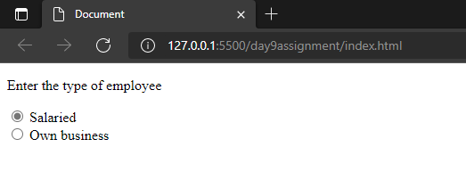

- Design form shown in the link (http://evc-cit.info/cit040/formguide/card_0.png)
Code:
Index.html:
<!DOCTYPE html>
<html lang="en">
<head>
<meta charset="UTF-8">
<meta http-equiv="X-UA-Compatible" content="IE=edge">
<meta name="viewport" content="width=device-width, initial-scale=1.0">
<title>Document</title>
<link rel="stylesheet" href="style.css" type="text/css">
</head>
<body>
<div>
<form>
<fieldset>
<p>Yes! I want to subscribe to <i>MAG-O-Zine</i></p>
<div id="textfields">
<label>First Name</label><input type="text" name="firstname">
<label>Last Name</label><input type="text" name="lastname">
<br>
<label>Address</label><input type="text" name="address">
<br>
<label>City</label><input type="text" name="city">
<label>State</label><input type="text" name="state">
<label>Zip</label><input type="text" name="zip">
<br>
</div>
<label>Subscribe for:</label>
<input type="radio" name="subscribe" value="1 year"><label>1 year($19.95)</label>
<input type="radio" name="subscribe" value="2 year"><label>2 year($35)</label>
<br>
<label>Send me more information about:</label><br>
<input type="checkbox" name="info" value="Computer-o-zine"><label>Computer-O-Zine</label><br>
<input type="checkbox" name="info" value="fishing-zine"><label>Fishing-Zine</label><br>
<input type="checkbox" name="info" value="cat-o-zine"><label>Cat-O-Zine</label><br>
</fieldset>
</form>
</div>
</body>
</html>
Style.css:
p{
background-color: red;
color:white;
font-size:20px;
font-family: Arial, Helvetica, sans-serif;
font-weight:bold;
text-align: center;
}
#textfields input{
border:none;
border-top:1px solid #000000;
display: inline-block;
position:relative;
}
fieldset{
display: inline;
}
#textfields label{
display:inline-block;
padding-top: 1.5em;
font-family:'Segoe UI', Tahoma, Geneva, Verdana, sans-serif;
font-size:12px;
}
Output:
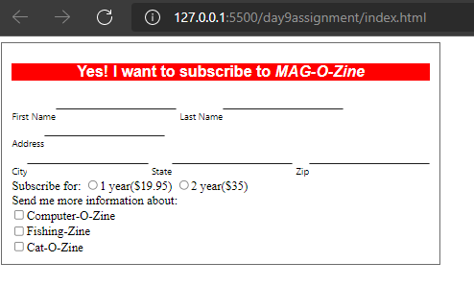
- Use the table tag to design given image Click here.
Code:
<!DOCTYPE html>
<html lang="en">
<head>
<meta charset="UTF-8">
<meta http-equiv="X-UA-Compatible" content="IE=edge">
<meta name="viewport" content="width=<device-width>, initial-scale=1.0">
<title>Document</title>
<style>
table,
tr,
td {
border: 1px solid black;
border-collapse: collapse;
padding: 10px;
}
h4{
margin-bottom: -5px;
}
td {
text-align: center;
}
</style>
</head>
<body>
<div align="center">
<h4>Health chart</h4><br>
<table>
<tr>
<td rowspan="2">State of Health</td>
<td colspan="2">Fasting Value</td>
<td>After Eating</td>
</tr>
<tr>
<td>Minimum</td>
<td>Maximum</td>
<td>2 hours after eating</td>
</tr>
<tr>
<td>Healthy</td>
<td>70</td>
<td>100</td>
<td>Less than 140</td>
</tr>
<tr>
<td>Pre-Diabetes</td>
<td>101</td>
<td>126</td>
<td>140-200</td>
</tr>
<tr>
<td>Diabetes</td>
<td>More than 126</td>
<td>N/A</td>
<td>More than 200</td>
</tr>
</table>
</div>
</body>
</html>
Output:
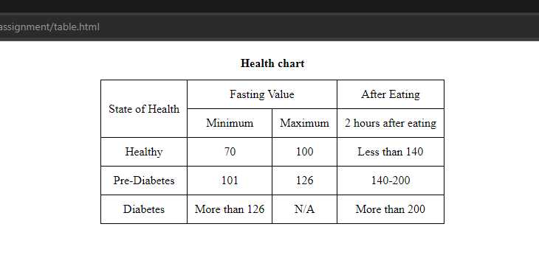

- Write HTML input tags snippet to show default values for all Form elements.
<!DOCTYPE html>
<html lang="en">
<head>
<meta charset="UTF-8">
<meta http-equiv="X-UA-Compatible" content="IE=edge">
<meta name="viewport" content="width=device-width, initial-scale=1.0">
<title>Document</title>
</head>
<body>
<form>
<label>Text</label>
<input type="text" name="name" value="reevan">
<label><i>---Default value is reevan</i></label>
<br><br>
<label>Password</label>
<input type="password" name="password" value="1234">
<label><i>---default password is 1234</i></label>
<br><br>
<label>Color</label>
<input type="color" name="color" value="#00FF00">
<label><i>---default color is #00ff00</i></label>
<br><br>
<label>Date</label>
<input type="date" name="date" value="2021-05-27">
<label><i>---default date is 2021-05-27.</i></label>
<br><br>
<label>email</label>
<input type="email" name="email" value="reevan@gmail.com">
<label><i>---default email is reevan@gmail.com.</i></label>
<br><br>

<label>Range</label>
<input type="range" name="range" value="90">
<label><i>---default range is 90.</i></label>
<br><br>
<label>Time</label>
<input type="time" name="time" value="09:40">
<label><i>---default time is 9:40</i></label>
<br><br>
<label>Radio</label>
<input type="radio" name="animal" value="dog" checked>Dog
<input type="radio" name="animal" value="cat">Cat
<label><i>---by default dog will be checked</i></label>
<br><br>
<label>Checkbox</label>
<input type="checkbox" name="animal" value="dog" checked>Dog
<input type="checkbox" name="animal" value="cat" checked>Cat
<input type="checkbox" name="animal" value="tiger">Tiger
<label><i>---By default dog and cat will be checked</i></label>
<br><br>
</form>

</body>
</html>
Output:
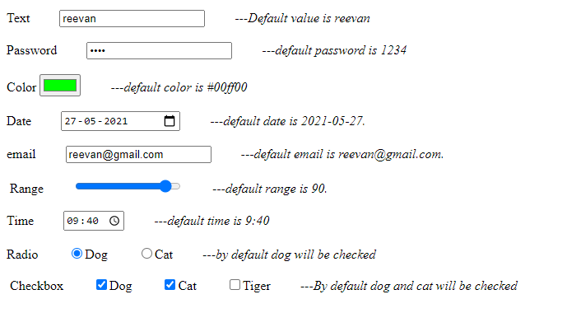

- In your, HTML page add the below line and Highlight it without using any CSS.
"HTML & CSS is awesome"
Code:
<!DOCTYPE html>
<html lang="en">
<head>
<meta charset="UTF-8">
<meta http-equiv="X-UA-Compatible" content="IE=edge">
<meta name="viewport" content="width=device-width, initial-scale=1.0">
<title>Document</title>
</head>
<body>
<p><mark>HTML & CSS is awesome</mark><p>
</body>
</html>

Output:
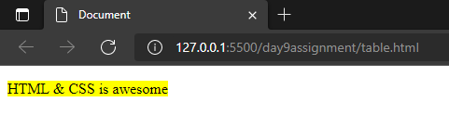

- Create an HTML page, which should contain all types of input elements.
<!DOCTYPE html>
<html lang="en">
<head>
<meta charset="UTF-8">
<meta http-equiv="X-UA-Compatible" content="IE=edge">
<meta name="viewport" content="width=device-width, initial-scale=1.0">
<title>Document</title>
</head>
<body>
<form method="" action="">
<label>Text</label>
<input type="text" name="name" placeholder="Enter your name...">
<label><i>---Here in this field we can enter text</i></label>
<br><br>

<label>Password</label>
<input type="password" name="password" placeholder="Enter your password">
<label><i>---this type is used to enter password</i></label>
<br><br>
<label>Radio</label>
<input type="radio" name="animal" value="Dog">Dog
<input type="radio" name="animal" value="Cat">Cat
<label><i>---This is used to select one field from number of choices</i></label>
<br><br>
<label>Checkbox</label>
<input type="checkbox" name="animal" value="Dog">Dog
<input type="checkbox" name="animal" value="Cat">Cat
<input type="checkbox" name="animal" value="Tiger">Tiger
<label><i>---This is used to select zero or more choices</i></label>
<br><br>
<label>Color</label>
<input type="color" name="color" value="#00FF00">
<label><i>---Here a color can be picked from a color picker. Value will give the default color.</i></label>
<br><br>
<label>Date</label>
<input type="Date" name="date">
<label><i>---Using this we can select a particular date.</i></label>
<br><br>
<label>Datetime-local</label>
<input type="datetime-local" name="time">
<label><i>---Using this we can select both date and time.</i></label>
<br><br>
<label>email</label>
<input type="email" name="email">
<label><i>---This will allow us to enter email, it will throw an error if anything else entered other than email.</i></label>
<br><br>
<label>file</label>
<input type="file" name="file">
<label><i>---This will allow us to select file from the device.</i></label>
<br><br>
<label>Month</label>
<input type="month" name="month">
<label><i>---Using this we can select month of a particular year</i></label>
<br><br>
<label>Number</label>
<input type="number" name="number" min="1" max="5">
<label><i>---Here we can select a specific nuber, min and max represents minimum value and maximum value that can be selected.</i></label>
<br><br>
<label>Range</label>
<input type="range" name="vol" min="0" max="50">
<label><i>---Here we can select a value from range of values.</i></label>
<br><br>
<label>Search</label>
<input type="search" name="search">
<label><i>---This is used for search field.</i></label>
<br><br>
<label>Tel</label>
<input type="tel" name="phone" pattern="[0-9]{10}">
<label><i>---In this field we can enter phone number where pattern indicates it should contacin 10 numbers between 0 to 9.</i></label>
<br><br>

<label>URL</label>
<input type="url" name="url">
<label><i>---This field can be used to enter URLs.</i></label>
<br><br>
<label>Week</label>
<input type="week" name="week">
<label><i>---This field upon selecting the date will gave the number of week the date is in that particular year.</i></label>
<br><br>
<label>button</label>
<input type="button" value="Click me">
<br><br>
<label>Submit</label>
<input type="submit" value="submit">
<label><i>---submitting data to a form handler</i></label>
<br><br>
<label>Reset</label>
<input type="reset">
<label><i>---It will reset all form values to the default values</i></label>
</form>
</body>
</html>

Output:
